LANDING PERMIT for non-scheduled flight

Hanoi, 31/07/2026
Permit No.: LD-8072/07/2026VN

1. Carrier/Operator:
Name: VISTAJET LIMITED
IATA Code: | ICAO Code: VJT
Address: SKYPARKS BUSINESS CENTRE, LUQA LQA 4000, MALTA
Tel: +84 943 448 898 | Email: operations@havaviation.com

2. Schedules (UTC Time)
Flight Number | Effective From | Effective To | Days Of Services | Departure Airport | ETD | Arrival Airport | ETA
VJT503 | 02AUG26 | 02AUG26 | 7 | SZB | 0400 | SGN | 0600
VJT503 | 02AUG26 | 02AUG26 | 7 | SGN | 2230 | HAN | 0035+1
VJT503 | 03AUG26 | 03AUG26 | 1 | HAN | 0600 | SGN | 0805
VJT503 | 04AUG26 | 04AUG26 | 2 | SGN | 0000 | SZB | 0140

3. Purpose Of Flight: Business Flight
SZB-SGN-HAN-SGN-SZB: 4 PAX
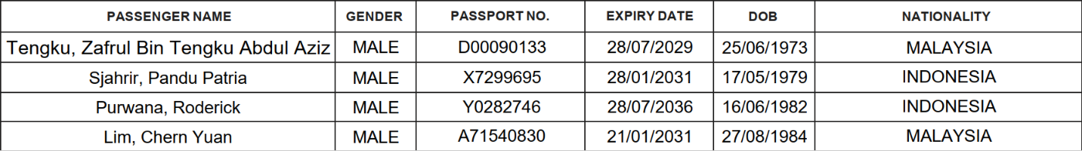

4. Aircraft
Aircraft Type | Registration Marks
CL60 | 9H-VFA

5. Airways
Sector | Airways
SZB-SGN | M765-L637
SGN-HAN | Q2
HAN-SGN | Q1-W1
SGN-SZB | L637-M765
Other permitted airways published in Viet Nam’s AIP

6. Validity: -12/+24 HOURS WINDOW FOR PSBL DELAY
HA ANH FOR BUI MINH DANG- DIR OF ATD-CAAV

